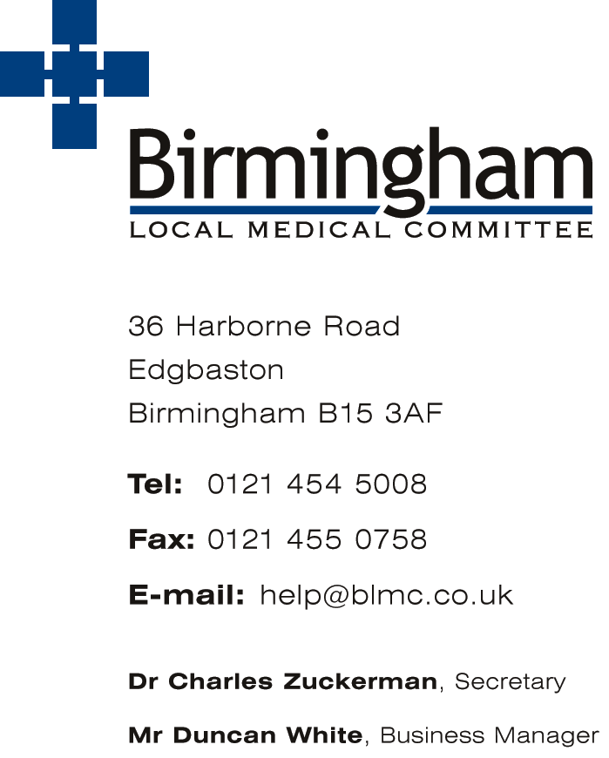
Seymour House
15A Frederick Road, Edgbaston,
Birmingham B15 1JD

T 0121 454 5008
www: http://blmc.co.uk
lmcadmin@blmc.co.uk

Miss Wendy Loveridge, Director of Practice Support and Committee Secretary
Mrs Julie Mason, Director of Operations, Finance and
Business Management

15th July 2020
Supporting the Business of General Practice

Re: Guidance note for patients requesting exemption letters

We are aware that some patients might be understandably anxious about the Government’s recent announcements around the use of face masks in various public settings.

GPs are unfortunately not in a position to provide individual risk assessments or letters for patients who feel that they should be exempt from wearing a face mask.

Birmingham Local Medical Committee has therefore prepared this guidance note as the statutory body that advises and supports all GPs and practice teams across Birmingham.

The government guidance on exemptions suggests there is no requirement for evidence for exemption therefore it is sufficient for an individual to self-declare this.

The responsibility for issuing exemptions lies with the transport provider, shops and supermarkets not your GP. Similarly, practices are under no obligation to provide letters of support for anyone who does not fall under the list of exemptions but considers them to have another reason to be exempted.

Government advice on the use of face coverings can be found here:

https://www.gov.uk/government/publications/face-coverings-when-to-wear-one-and-how-to-make-your-own/face-coverings-when-to-wear-one-and-how-to-make-your-own

Some people don’t have to wear a face covering including for health, age or equality reasons. Some transport, shops and supermarket staff may not wear a face covering if it is not required for their job.

We hope that this guidance provides some reassurance for you on this issue.

Yours sincerely

Miss Wendy Loveridge
Committee Secretary / Director of Practice Support

