EXTRAORDINARY COVID-19 UPDATE
WEEKLY NEWSLETTER – 9th February 2021

- Vaccination of JCVI cohorts 1-4 including additional housebound supplement
- Movement of AstraZeneca vaccines
- National call/recall letters to Clinically Extremely Vulnerable people
- Vaccine Cohorts – Message from the COVID Vaccination Team
- Second doses
- New vaccination information helpline and alternative point of care systems
- Vaccinations for Health Care Workers on Statutory Leave
- Vaccine doses data
- Freedom of Information Act Request - UPDATE

1. Vaccination of JCVI cohorts 1-4 including additional housebound supplement
NHSE/I wrote a letter to LVS sites last week, to remind them that everyone in JCVI cohorts 1-4 should be offered the opportunity to be vaccinated by Monday 15 February, and to try to minimise any inequalities in vaccine uptake between different patient groups in those cohort wherever possible. NHSE/I are asking each PCN site to confirm that they have made an offer to all patients in cohorts 1-4 by the 15th by filling in the form in this link. This was requested to be completed by close of play 08.02.2021
If a vaccination site does not believe they have sufficient vaccine to complete this, they should contact NHSE/I through their local system as soon as possible so that additional supplies can be provided.
The letter also included details about a welcome additional supplement of £10 per visit to a housebound patient to administer the COVID-19 vaccinations. This supplement is on top of the £12.58 Item of Service fee. The supplement applies retrospectively to any first dose vaccinations since 14 December 2020, and second doses within the arrangement.
Coronavirus » Making the universal offer of vaccination to JCVI cohorts 1-4 ahead of February 15, and additional funding for vaccination of housebound patients (england.nhs.uk)

2. Movement of AstraZeneca vaccines
Moving the AstraZeneca/Oxford vaccine between locations across a single PCN grouping is both encouraged and legal if it will help minimise inequalities, maximise access and ensure timely vaccine usage. The BMA believe the delivery of vaccination from local practices will enable more patients to access and receive the vaccine and would expect local systems to support this. The Standard Operating Procedures, outlines the cold chain arrangements which need to be adhered to do this. See more information in the NHSE/I letter of 7 January 2021.
NHSE/I has also published a position statement for the vaccination of care home residents using COVID-19 Vaccine AstraZeneca (AZ), recommending that when planning a vaccination session for local care homes, a risk assessment should be undertaken to identify the risk factors associated with the transfer of the vaccine for administration to remaining care home patients.
Annex B of the recent NHSE/I document Mutual aid and the transfer of COVID-19 vaccines between Hospital Hubs, Vaccination Centres and Local Vaccination Services sets out that as long as the relevant guidance is followed, local commissioners should be offering a supportive role in facilitating the movement of the AZ vaccine within a PCN grouping and do not need to seek formal approval for moving the vaccine in line with the arrangements set out in the letter. It also advises that once moved, the vaccine should either be administered or immediately put in a refrigerator at a practice site within the PCN grouping, and ideally administered within 24 hours or over the following days.

3. National call/recall letters to Clinically Extremely Vulnerable people
As of 3 February, people aged 18 and over in the clinically extremely vulnerable (CEV) cohort (as identified through the Shielded Patient List) will receive letters from the national call/recall service informing them that they are now eligible to receive their COVID-19 vaccine. The letters make it clear that people have a choice of where to get vaccinated and can choose to wait for their GP services to contact them directly, if they haven’t already, or book into a vaccination centre or community pharmacy. A copy of the letter and a PCN letter template (Enc.1) are available in the letter pack on the FutureNHS platform (sign in required).
It is concerning that these letters are not directly linked to a patient’s local GP vaccination service, nor the stage at which the local area has reached in terms of vaccination coverage, and the BMA are continuing to discuss how to improve this with NHSE/I.

4. Vaccine Cohorts – Message from the COVID Vaccination Team
Please see the message below received from the COVID Vaccination Team on 06.02.2021 with regards to the circumstances whereby vaccinating patients outside of JCVI Cohorts 1-4 is permissible.
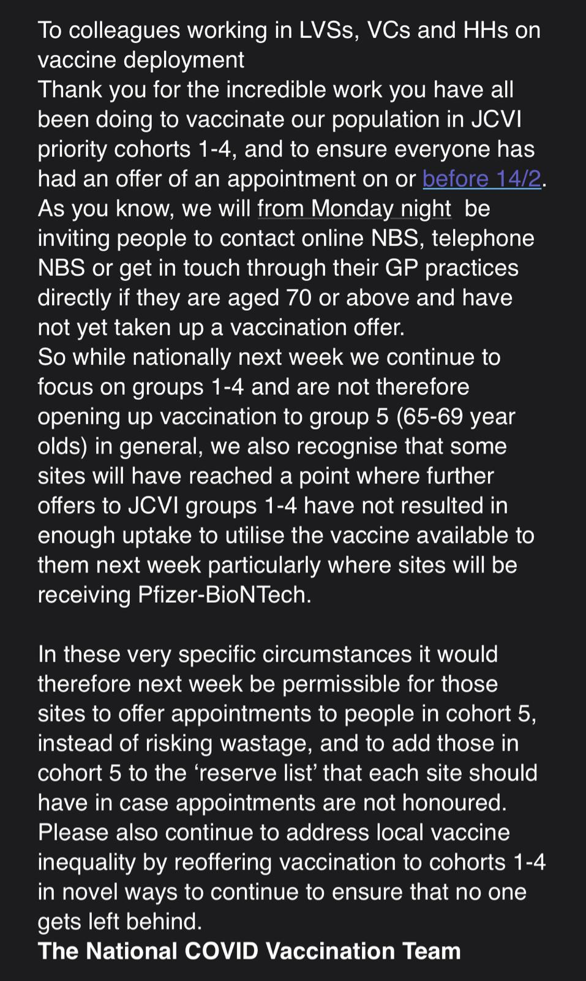

5. Second doses
Chapter 14a (on COVID-19) of the ‘The Green Book’ has been updated for patients due to start immunosuppressive treatment, so that for example, if prior to cancer the patient has had therapy or a solid organ transplant they could be offered a vaccine prior to starting treatment, if clinically recommended. This includes potentially having the second dose at 3 or 4 weeks after the first.
Last week, the BMA raised with NHSE/I the need for practice sites to be able to start planning giving second doses by booking appointments. On Friday, LVS (Local Vaccination Service) sites were sent a message about the scheduling about preparing for the second dose vaccination clinics for cohorts 1-2 which should go live as of week commencing 1 March 2021. The allocated quantity of vaccines will be based on quantity of first dose delivered by site (full pack unless a pack-down option was provided). The second dose clinics will take place 11 weeks post first dose clinics so the 12 week lead time between doses is achieved. Practice sites should be provided with scheduled delivery day of second dose volumes by the end of this week, and are asked to schedule clinics up to the end of March once delivery schedule by day has been communicated.
The BMA also believe it would be reasonable for GP sites to now give all those patients who have received the AstraZeneca vaccine an appointment for a second dose, and to do this for these patients when the first dose is given to reduce the workload involved in contacting patients at a separate time.

6. New vaccination information helpline and alternative point of care systems
A new COVID-19 vaccination information web resource and helpdesk has been set up for practice managers to help you find out answers to questions about records of vaccinations.
New assured point of care systems for recording COVID-19 vaccinations will also be available soon for practices which can be used as an alternative to Pinnacle. This provides greater choice and reduces reliance on any one supplier. As currently happens, all the data will flow into the GP record within 48 hours. These developments are in direct response to requests from GPC England on behalf of general practice.
Find out more information about your COVID-19 vaccination queries, how the vaccinations are recorded, common errors or difficulties and how to get help in these FAQs by NHS Digital.

7. Vaccinations for Health Care Workers on Statutory Leave

Birmingham LMC received queries as to the policy for vaccinating sessional GP’s who are currently on maternity leave or long term sick leave and whether these workers would still be able to receive vaccination under the 2nd Priority cohort?
We have today received confirmation from the CCG that the opinion of the clinical lead for the programme is that they should be vaccinated if they wish.

8. Vaccine doses data
This week, we are celebrating the milestone of over 10 million COVID-19 vaccination doses having been given in the UK, which has risen to almost 11 million today, and the latest data report , show that as of 3 February a total of 9,126,930 doses have been given in England. This is an enormous achievement, in particular when practices have also provided millions of flu and childhood immunisations this year. Thank you to all those who have made this possible so quickly.
The most recent BMA vaccine survey, which aims to track the roll out of first and second vaccine doses among members UK wide, shows that as of 29 January:
93% have received one or both doses
13% have received both doses
5% have are still to receive a single dose
Almost half (46%) of those who have received their first dose have a date for a second dose - the majority expect this to be in 10-12 weeks’ time.

The survey also showed that with regards to ethnicity and being at higher clinical risk, there is no difference in one or both vaccine dose rate by ethnicity (BAME doctors 94%, white doctors 93%) or by being at a higher clinical risk (higher risk 94%, not at higher risk 94%).

Freedom of Information Act Request - UPDATE

1. FOI – learning disabilities to identify those recorded as DNAR
The BMA have been advised that practices may wish to respond to say that the QI modules have been deprioritised and income protected and link to the relevant NHSEI letter (therefore the data is incomplete/inaccurate because of the changes made to support practices in managing the pandemic) and ask if they still wish to receive this data. This does not absolve practices of their responsibility to provide the data requested.
If they still want the data then practices do have to provide it. It is important to remember that practices do not have to create new information to satisfy an FOIA request (ie they don’t have to do the QI module in order to provide the info). If the data requested (number of patients with learning disabilities recorded as DNAR, numbers that have been amended to remove this DNAR, and the age of each patient) can be ascertained from existing data then practices must provide it, but they might want to give some additional info in order to provide context around the data (eg reviews have not been carried out for all patients as this work has been deprioritised by NHSEI for most of the year).
If identifying the information and creating the response would be over the appropriate threshold of 18 hours work then the FOI can be politely rejected.

Please note that the LMC are unable to accept calls or hold communications with patients, we are GP representatives, and we would respectfully ask that Practices do not advise patients to contact us

Please note our office contact times remain 10:00-16:00 and any queries on the day should be directed to birmingham.lmc@nhs.net

Helpful Links:

BMA COVID-19: toolkit for GPs and GP practices https://www.bma.org.uk/advice-and-support/covid-19/gp-practices/covid-19-toolkit-for-gps-and-gp-practices Comprehensive guidance for GPs, partners, and practice managers to manage employment and contractual issues and service provision during the coronavirus pandemic.

GOVERNMENT WEBSITE: https://www.gov.uk/coronavirus for recent and upcoming changes, guidance & support.

NHS ENGLAND: https://www.england.nhs.uk/publication/implementing-phase-3-of-the-nhs-response-to-the-covid-19-pandemic/

