WEEKLY NEWSLETTER -
- New provider announcement – BSol ICS
- New: Warning about phishing email
- Update on NHS Property Services (NHSPS) Legal case
- Risk assessments for practices
- GP abuse
- Rebuild
- Accelerated access to patient records
- Monkeypox
- Initial Health Assessment services in support of new arrivals from Ukraine
- Safe surgeries survey
- Fit Notes
- BMA Employer Advisory Service
- Resources for Local Assurance Framework
- Referrals not made via E-RS – Reminder for practices
- PCSE Update**This is for information only. Practices DO NOT need to take any further action and DO NOT need to reply to this email**

1. New provider announcement – BSol ICS
Since August 2019, Birmingham and Solihull primary care clinicians have identified those at risk of developing Type 2 diabetes and offered referral into the Healthier You: NHS Diabetes Prevention Programme (NHS DPP) - a behaviour change programme. The local NDPP Service Provider has been WW. WW will continue to deliver the NDPP under contract with NHSEI until 30 June 2022.
From 1 August 2022, a new Provider, LWTC, will deliver the NDPP for Birmingham and Solihull patients. BSol ICS will continue to monitor the local services to ensure there is minimal disruption to patients and clinicians during the period of transition between providers.
Please continue to refer patients with Non-Diabetic Hyperglycaemia (HbA1c of 42-47mmol/mol) into the NDPP through your usual route until further notice. We will be working with IT to ensure clinical templates are updated accordingly and will keep you informed of progress.

2. New: Warning about phishing email
We have been made aware of a phishing email being sent to NHS staff that appears to be from an NHSE/I finance team; a copy of the text from the email is highlighted, in blue below:
Dear Colleague
NHS England/Improvement are conducting user research to identify ways to improve the user experience of the Integrated Single Financial Environment (ISFE) service across NHS organisations.
As part of ongoing research, a list of ‘user needs’ have been identified. ‘User needs’ are the needs that a user has of a service, and which that service is required to satisfy for the user to get the right outcome for them e.g. a task or a goal.
As a current ISFE user, you have been randomly selected to complete the survey (please follow the link below) which presents you with a selection of those user needs identified in our research to date (35 in total) and asks you to review and rank their importance for you in your current role. This should take around 15 minutes of your time.
Important to note: there are needs which have already been categorised as essential (e.g. "I need to raise a requisition", "I need to complete a payment run") and so these have not been included. If you have any unmet needs which are not presented in this survey, you have the opportunity at the end of the survey to submit your own examples that the ISFE service should consider
Many thanks for your continued support.
This email is spam and if you do receive it, please forward the email as an attachment to spamreports@nhs.net and then delete it.

3. Update on NHS Property Services (NHSPS) legal case
Since early 2020, the BMA has been supporting 5 GP practices in legal dispute with NHS Property Services (NHSPS) around inflated service charges. The case has been broken into two phases by the court: phase one to look into the principles of which services NHSPS can charge the practices for, and phase two to look into what the exact amounts of any charges will be. We have now received the judgment on phase one of the trial, and in determining which services practices are liable to pay, the court has decided in favour of NHSPS.
The complex judgment is 170 pages long, and gives some clarity to these practices about what services they are and are not obliged to pay for. The length of the judgment underlines the difficulties caused by the drastic change in approach by NHSPS to service charges that busy practices, working to provide care to patients under the most difficult circumstances, are being forced to navigate.
These proceedings were initially launched because NHSPS appeared to be increasing GP practices’ service charges in reliance on its Consolidated Charging Policy. However, in June 2020 NHSPS conceded that its charging policy did not impliedly vary these practices’ obligations retrospectively, and the recent judgment confirms that in none of the five practices’ cases was NHSPS’ charging policy incorporated into the terms of their tenancy.
GP practices’ service charge obligations can only be determined on a case-by-case basis. The judgment confirms that practices facing demands for fees that they do not understand should take a constructive approach, and seek their own advice to investigate what is and is not recoverable by way of service charges. This has always been our approach and we have consistently advised practices to do their own due diligence.
During these proceedings we have seen NHSPS’ claims for outstanding service charges revised vastly, in one case being reduced by as much as 34% (more than £178,000). This underlines the opacity of NHSPS’ methods for calculating charges. Had the BMA not supported the GP practices in this case to defend NHSPS’ claims for charges they could have overpaid hundreds of thousands of pounds to NHSPS, which NHSPS was unable to substantiate when required to do so.
The case is not over, with the next stage to determine how much these practices may owe, if indeed they received the services to the required standard or even at all. We are discussing our next steps with the legal team, and will provide further updates and guidance as they become available.

4. Risk assessment for practices
We have revised our guidance on COVID-19 risk assessment for practices, following the updated
NHSE/I national infection prevention and control (IPC) manual for England.
The IPC manual is clear about the need for local risk assessments for staff in contact with COVID-19, which is particularly important now that the requirement for social distancing and mask wearing is no longer obligatory. It is still the employer’s responsibility to ensure safe working for staff, and thus a risk assessment should still be carried out and appropriate mitigations.
People who come to GP practices are more likely to be ill or clinically vulnerable, so it’s vital that practices are able to exercise discretion to protect patients and staff. Especially in the context of rising abuse towards practice staff, people must be assured that if practices are asking them to continue wearing masks this is for the safety of everyone in the building.
The BMA will support practices and doctors who continue to ask patients and staff to wear face masks where they feel this is necessary.

5. GP abuse
A recent BMJ investigation found that the number of violent incidents at UK general practices recorded by police forces has almost doubled in the past five years.
In response to this, Dr Chaand Nagpaul, BMA council chair, said: “We fundamentally need the Government to be open and honest with the public that the real reason patients don't have the level of service they deserve is due to the fact we have severe shortages of GPs and a lack of capacity to meet record demand. We also need ministers to make clear to the public that there will be zero tolerance to abuse, violence and threats against GPs and their staff, and that swift action will be taken against any offenders.” Read the full BMA response
Download our poster against GP abuse

6. Rebuild General Practice: 3 ways to show your support
Help us build awareness of the crisis facing general practice. Your support to amplify the message will help make the campaign a success. Here are three ways to get involved.
Sign the ‘Letter to my patients’
Hundreds of GPs have already signed an open letter to our patients - showing them that GPs are on their side. To add your signature, simply email hello@rebuildgp.co.uk with your full name.
Use #RebuildGP
Follow and share content, news, and updates on the campaign Twitter page
Access campaign materials
Contact your LMC for more information and to access campaign materials.

7. Accelerated access to patient records
We would like to update you on developments with regard to the provision of prospective access to patient records. This new service was due to go live at the end of 2021 but was delayed due to concerns from the profession. The Secretary of State has now confirmed a launch date of 1 November 2022.
The GP Committee’s IT Policy Group has been having weekly calls with NHS England and has participated in several workshops looking at clinical safety issues, redaction and guidance documents. We have worked with system suppliers and with safeguarding leads and we hope mitigations will be in place to address any ongoing safety concerns. We are also awaiting feedback from early adopter sites.
There are several steps that practices need to take between now and the launch date and we will provide guidance on this shortly.
Work is still ongoing and we are making all necessary representations, and continue to highlight the potential concerns of the profession. If you have any questions, you can contact us via info.gpc@bma.org.uk

8. Monkeypox
Whilst the risk of monkeypox infection remain low, the UK Health Security Agency (UKHSA) is asking people to be alert to any new rashes or lesions on any part of their body.
If you are concerned that a patient may have contracted the disease, use appropriate PPE, including mask and gloves. For confirmed cases of Monkeypox, UKHSA guidance states that FFP3 respirators should be used. Isolate the person whilst seeking advice on next steps from the local sexual health clinic for urgent advice or your local health protection team, and ensure the consultation room is cleaned appropriately afterwards based on UKHPA advice.
Monkeypox is now a designated a notifiable infectious disease under the Health Protection (Notification) Regulations 2010. This means all doctors in England are required to notify their local council or local Health Protection Team (HPT) if they suspect a patient has monkeypox.
We have raised concerns with NHS England that specific guidance for primary care has not been provided in relation to the latest outbreak of Monkeypox.
Further information is available on the UKHSA website.

9. Initial Health Assessment services in support of new arrivals from Ukraine
In order to support Ukrainian refugees arriving in England, NHSE/I is asking CCGs to commission Initial Health Assessment services in support of new arrivals from Ukraine. Whilst CCGs will be free to determine how best to undertake this, and who from, NHSE have developed an outline specification and a template Local Enhanced Service to support delivery by patients’ own registered GP practice when they register, should practices wish to sign up. Details this can be found on the NHS England website.
The DHSC has also published bilingual versions of the GMS1 registration form:
English / Ukrainian: https://www.gov.uk/government/publications/gms1.uk
English / Russian - https://www.gov.uk/government/publications/gms1.ru

10. Safe surgeries survey
Doctors of the World wants to hear from general practice staff to find better ways to support staff and patients to ensure that everyone can register with a GP. Part of this work will be used to evaluate the DOTW UK Safe Surgeries Initiative, a BMA-endorsed programme and toolkit that supports GP practices to become more accessible to socially excluded groups. Please complete a 5 minute survey by 20 June 2022.
If you’re interested in participating in a short, please contact Kerrie at k.stevenson@ucl.ac.uk

11. Fit Notes
From 1 July, new legislation will be enacted which will allow nurses, occupational therapists, pharmacists, and physiotherapists to legally certify fit notes, in addition to doctors who are currently the only profession able to do so.
Non-statutory guidance has been developed to help individuals identify if this task is within their scope of practice as well as a new training module which should be completed before taking up this task. These new products will be available from 1 July. There will be a rollout period from this date where GP IT systems will be updated to reflect the change.

12. BMA Employer Advisory Service
As a membership benefit, the BMA provides an employer advice service for GP partners and your practice managers. With no expensive contracts, you can get tailored advice from the BMA’s specialist team of HR & employment advisers and regulatory knowledge, who can support you with:

– HR & employment law case management

– reviewing HR documentation and ensuring legal compliance

– employment tribunal support, and much more.

The service is available to BMA members - contact the BMA GP employer advisory service

13. Resources for Local Assurance Framework
The Digital Team are seeking support from Practice Managers, Business Managers or Data Protection Officers that have completed a data protection course. As part of the Local Assurance Framework, the team assesses the safety of using the product and the storage of patient data. Within this there is a section dedicated to Information Governance where the team reviews i.e. DPA’s, DPIA’s, breach policies, any comments are co-ordinated and reported back to the supplier. We would like to expand the number of Subject Matter Experts (SME) to help review these sections. We would pair a new recruit with an existing SME and take you through the process.
The idea is that we create a pool of resources that we can select from. It would be around 1-2 hours per week depending on how many additional personnel we can recruit. If we manage to recruit enough people it may be less, around 1-2 hours every other week.
We feel this would be a great learning experience and opportunity if anyone was interested, and of course you would be remunerated.
The hourly CCG budget for Clinical staff is: £85 per hour. Practice or Business Manager is £35 per hour. This reimbursement would be payable direct to your practice.
If you would like more information please email: kate.thomas7@nhs.net.

14. Referrals not made via E-RS – Reminder for practices

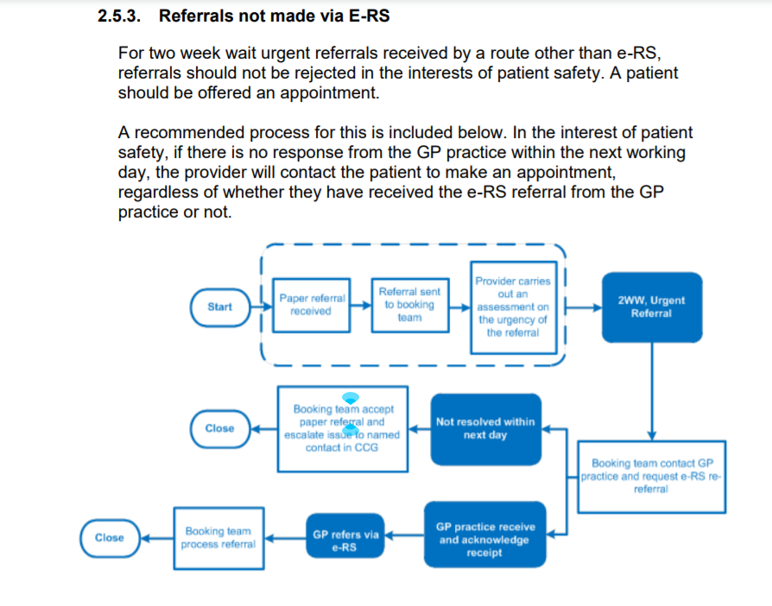
BMA position as follows:
Referrals from non-medical professionals
Referrals from non-medical professionals - for example, dentists, physiotherapists and optometrists - to secondary care settings cannot currently be made using e-RS.
What should be in place
Existing referral processes should remain in place for all referrals that cannot be made via e-RS.
Patients should not be adversely affected because their referral has not been made through e-RS. This could mean blocking out a portion of outpatient appointments for non-e-RS referrals.
The use of e-RS, if not already, will be extended to all allied health professionals who regularly refer patients to specialist services.
Here: https://www.bma.org.uk/advice-and-support/nhs-delivery-and-workforce/primary-and-secondary-care/nhs-e-referral-service-for-secondary-care-doctors

15.PCSE Update **This is for information only. Practices DO NOT need to take any further action and DO NOT need to reply to this email**
Dear Practice Manager (you have been blind copied into this email),
Please see the communication below from PCSE.
A small number of practices across England have been affected by an error with the calculation of the 2021/22 QOF achievement payments.
PCSE have identified the error, and will be contacting us if any practices in our region have been affected.
Please note that all 2021/22 QOF payments which have been declared will still be paid in the June Open Exeter statements (including those affected by the error).
In cases where a practice has been underpaid, PCSE will send NHS England a list of any affected practices and will provide details of the adjustments which we will then share with the affected practices. These adjustment payments will be made by PCSE.

In cases where a practice has been overpaid, or has received a duplicate payment, PCSE will contact the practice directly and will work with them to resolve the issue.

Please note our office contact times remain 10:00-16:00 and any queries on the day should be directed to birmingham.lmc@nhs.net. If you do call the offices, then please leave a message as this will be transferred direct to our emails and we can respond quicker.

Please note that the LMC are unable to accept calls or hold communications with patients, we are GP representatives, and we would respectfully ask that Practices do not advise patients to contact us. Could we also remind Practices that any copies of patient related correspondence MUST be anonymised as the LMC cannot accept patient identifiable data.

Helpful Links:

BMA Website: https://www.bma.org.uk/advice-and-support/gp-practices

GOVERNMENT Website: https://www.gov.uk/coronavirus for recent and upcoming changes, guidance & support.

NHS ENGLAND Website: https://www.england.nhs.uk/

